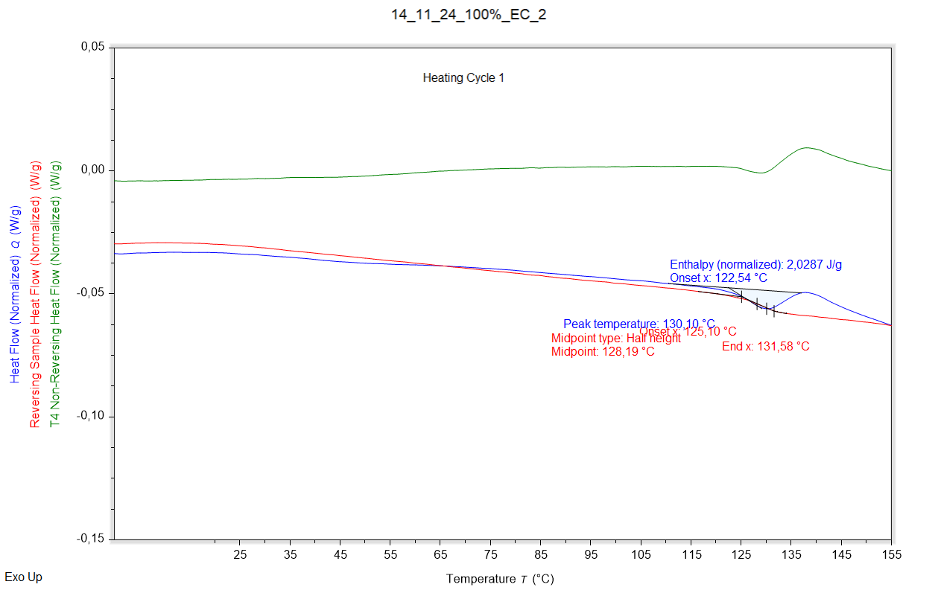

|  |  |  |  |
| --- | --- | --- | --- |
| Enthalpy recovery | Enthalpy recovery onset (°C) | Enthalpy recovery peak (°C) | Enthalpy recovery enthalpy (J/g) |
|  | 122,535 °C | 130,102 °C | 2,0287 J/g |

|  |  |  |  |
| --- | --- | --- | --- |
| Glass transition | Glass transition onset (°C) | Glass transition midpoint (°C) | Glass transition endpoint (°C) |
|  | 125,096 °C | 128,190 °C | 131,583 °C |

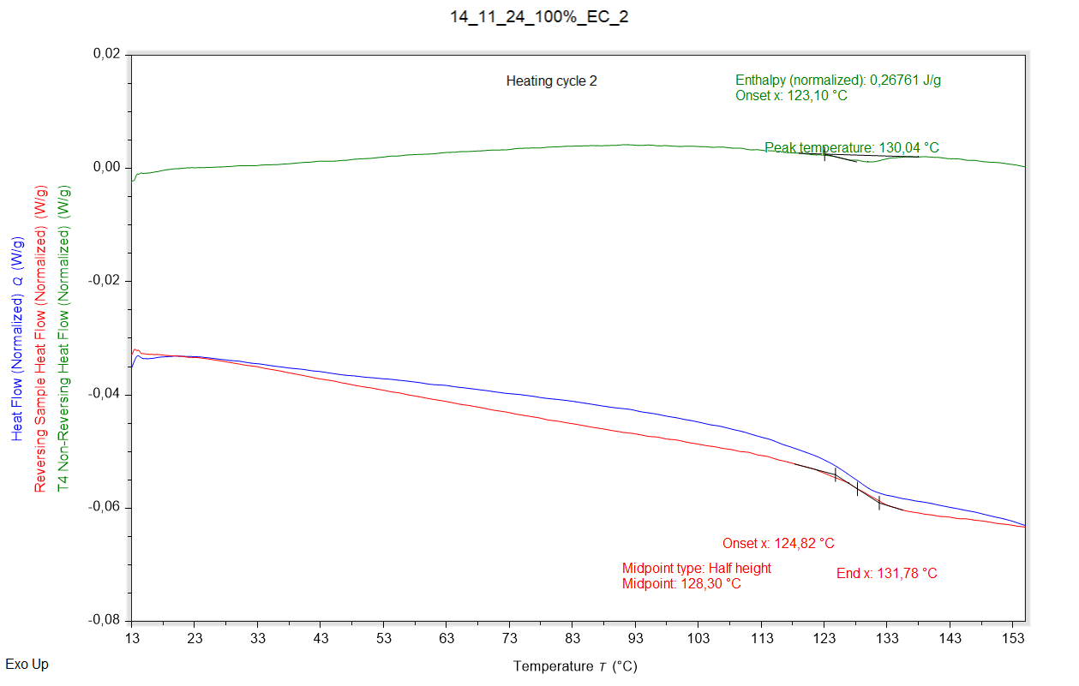

|  |  |  |  |
| --- | --- | --- | --- |
| Enthalpy recovery | Enthalpy recovery onset (°C) | Enthalpy recovery peak (°C) | Enthalpy recovery enthalpy (J/g) |
|  | 123,103 °C | 130,043 °C | 0,26761 J/g |

|  |  |  |  |
| --- | --- | --- | --- |
| Glass transition | Glass transition onset (°C) | Glass transition midpoint (°C) | Glass transition endpoint (°C) |
|  | 124,817 °C | 128,300 °C | 131,781 °C |